*X_TODAY_DATE_X*

**Customer Name: X_CUSTOMER_NAME_X**

**Quote Reference: X_QUOTE_REFERENCE_X**

**Site Details: X_SITE_DETAILS_X**

**Install Size: X_SYSTEM_SIZE_X**

**MPAN: X_MPAN_X**

Dear **X_CUSTOMER_FIRST_NAME_X,**

Many Thanks for your enquiry into the potential install of solar PV **X_SITE_DETAILS_X** please find below our quotation/contract following the site visit.

We are highly accredited in recognition for our track record of designing and delivering high quality renewable solutions and are a certified **Which? Trusted Trader**, as well as being approved by the **NFU Farm Energy**, all which command extremely high standards of both workmanship and ethical practices. We are also an **MCS** approved installer, **CHAS & Construction Line Gold** accredited as well as being members of **RECC** and **Trustmark** registered, ensuring best practice to all our clients. **Trustmark** is a government endorsed quality scheme which covers work for consumers in and around their home, offering you peace of mind that Environmental Energies has been thoroughly vetted to meet required standards and is committed to good customer service, technical competence, and trading practices.

Our approach is very straightforward, we manage the complete installation process, from design supply and installation to commissioning of the system, ensuring we deliver a fully comprehensive turn-key solar PV solution

We also offer an external monitoring service and varying options for Maintenance on PV systems. From remote monitoring only, through to a very comprehensive full maintenance package.

**Index**

1. Quotation Summary
2. Install Details
3. Performance Calculation
4. Upgrade Options
5. Summary of Warranties
6. Order Form
7. Cancellation Form
8. Express request for work to commence

I hope this quotation meets with your approval and If you have any questions or require further information please do not hesitate to contact me.

**Yours Sincerely**

**X_USER_NAME_X**

**X_USER_ROLE_X**

**Environmental Energies Ltd**

Note: All quotations are valid for 30 days from date of quotation, all goods specified are subject to availability at time of order.

1. **QUOTATION SUMMARY**

Further to our discussions, I can confirm that by utilising the suitable space available and working in line with your requirements and the roof space available we would look to install a **X_SYSTEM_SIZE_X** X_ROOF_MOUNT_TYPE_X Mounted Solar PV array made up of **X_NO_PANEL_X X** **X_PANEL_WATTS_X** and Solar Panels.

I have assumed the property will use X_POWER_USED_X of the power generated given the conversation we have had and predicted energy storage. The figures shown below are based on this information,

**Costs & Returns**

|  |  |  |
| --- | --- | --- |
| **Cost of PV System (exc VAT)** | **YIELD** | **EST. 20 YEAR PROFIT** |
| **XC1X** | **XC2X** | **XC3X** |
| **kWp Installed** | **Panels Required** | **Year 1 KwH Generated** |
| **XC4X** | **XC5X** | **XC6X** |
| **20 YEAR Co2 SAVINGS (Tonnes)** | **CO² per Year (Tonnes)** | **Payback Years** |
| **XC7X** | **XC8X** | **XC9X** |

*Annual expected Generation figures and returns are calculated in line with MCS standards, by using 22yrs of weather data taken from your local area, along with the information provided by you on your current energy costs and consumption.

1. **INSTALL DETAILS**

**Site**: **X_SITE_DETAILS_X**

**System: X_SYSTEM_SIZE_X**

**Components:**

|  |  |  |
| --- | --- | --- |
| **Item** | **Quantity** |  |
| XC1X | **XC2X** | **Yes** |
| Inverter | **XC3X** | **Yes** |
| Roof Mounting System |  | **XC4X** |
| Optimisers – Solar Edge |  | **XC5X** |
| Lifting Equipment, Scaffolding and Netting as required |  | **XC6X** |
| Waste Removal |  | **XC7X** |
| DC and AC Isolators |  | **XC8X** |
| DC and AC Wiring |  | **XC9X** |
| Connection to the distribution board |  | **XC10X** |
| Approved electrical generation meter |  | **XC11X** |
| Batteries Fox ESS |  | **XC12X** |
| EV Chargers |  | **XC13X** |
| Immersion Controller |  | **XC14X** |
| Pigeon proofing |  | **XC15X** |
| System Installation, commission, and warranties |  | **XC16X** |
| MCS registration |  | **XC17X** |
| Structural Report |  | **XC18X** |
| Monitoring Equipment – Customer Use Only – Via Inverter – Comms Cable by others |  | **Yes** |
| DNO Documents | TBC | **Yes** |
| Proposed Commencement Date | TBC |  |
| Proposed Completion Date | TBC |  |

**Exclusions:**

**Notes:**

1. The price of the Services is based on a continuous working period. If circumstances beyond our control necessitate a split programme of services, we reserve the right to charge for additional time in accordance with our Terms and Conditions of Business.

2. for full terms and conditions of business please see Environmental Energies Limited’s Terms of Business which are enclosed.

3. If additional services are required due to:

(i) Exceptional circumstances not reasonably foreseeable; or

(ii) If you request specification changes,

(iii) Equipment quoted may vary subject to stock at time of order

An estimate will be provided based on our hourly or daily rate.

4. Terms defined in Environmental Energies Limited’s Terms and Conditions of Business bear the same meaning when used in this quotation.

1. **PREDICTED PERFORMANCE CALCULATIONS MCS**

|  |  |
| --- | --- |
| Installation data | |
| Installed system capacity (kWp) | **XC1X** |
| Orientation of the System (Degrees) | XC2X |
| Inclination | **XC3X** |
| Postcode region | **XC4X** |
| Calculations | |
| kWh/kWp | **XC5X** |
| Shade factor | XC6X |
| Estimated annual output (kWh's) (SAP: kWp x Kk x SF) | **XC7X** |
| Estimated PV self-consumption-PV Only | |
| Assumed occupancy archetype | XC8X |
| Assumed annual electricity consumption, kWh | **XC9X** |
| Assumed annual electricity generation from solar PV system kWh | **XC10X** |
| Expected solar PV self-consumption (PV only) kWh | **XC11X** |
| **Grid electricity independence/Self-sufficiency (PV Only)%** | **XC12X** |
| Estimated PV self-consumption – with EESS | |
| Assumed usable capacity of electrical energy storage device, which is used for self-consumption, kWh |  |
| Expected solar PV self-consumption (with EESS) kWh |  |
| Grid electricity independence/Self-sufficiency (with EESS) % |  |

*Where there is an obvious clear horizon and no near or far shading the assessment of SF can be omitted and SF value of 1 used in all related calculations.*

**Predicted Returns Calculations** (N.B Prices exec Vat)

|  |  |  |  |  |  |  |  |  |
| --- | --- | --- | --- | --- | --- | --- | --- | --- |
|  | **Size (kWp)** | **Cost** | **Estimated Output (kWh/Annum)** | **Current cost of electricity** | **Inflation** | **YEAR ONE RETURNS**  **(Estimated)** | | |
| **System Type** | **Estimated Annual RPI** | **Electricity Saving** | **Predicted Export** | **Total Benefit** |
| **SOLAR PV** | **XC1X** | **XC2X** | **XC3X** | **XC4X** | **XC5X** | **XC6X** | **XC7X** | **XC8X** |
|  | **N.B Prices exec Vat** | | | |  |  | |  |

*The performance of Solar PV Systems is impossible to predict with certainty due to the variability in the amount of solar radiance (sunlight) from location to location and from year to year. This estimate is based upon the standard MCS Procedure and is given as guidance only. It should not be considered as a guarantee of performance. This system performance calculation has been undertaken using estimated values for array orientation, inclination, or shading. Actual performance may be lower or higher if the characteristics of the installed system vary from the estimated values.*

*This assessment has been undertaken using the standard MCS procedure* *– it is estimated that this method will yield results within 10% on the actual energy yield for most systems.*

***NB. Batteries and supplementary equipment such as Immersion Controllers are not MCS certified.***

1. **UPGRADE OPTIONS**

When visiting you to discuss your solar PV system our team will run through the options, they think are most appropriate and cost effective for your installation. If, however, the following upgrade options were not discussed, and you would like further information and/or a price please do not hesitate to contact us.

* 1. **Solar Edge**

Solar Edge optimises the performance of each panel individually, unlike a standard system where optimisation is over a string of panels. So instead of the string performing at the level of the worst performing panel in that string, Solar Edge allows each panel to have the optimum performance based on the irradiance level on that panel. As a result, Solar Edge systems can yield more than a standard inverter. There are also other benefits to Solar Edge including improved fire safety. If you would like more information about this system, please talk to us and we will supply an upgrade price.

* 1. **Immersion Controller – for excess generation**

A relatively low-cost solution for increasing your on-site consumption of the solar generation is to install an immersion controller. There are several devices available, and which is best for you will depend on how your immersion is wired and whether you want to monitor the device. Immersion controllers work by diverting unused generation to the immersion heater in your hot water tank*, rather than it is feeding back to the grid. Please contact us if you would like more information

*The immersion heater must be on its own dedicated supply for an immersion controller to be installed.

* 1. **Pigeon Proofing**

Occasionally we find that birds and other creatures may nest under solar panels. Obviously, this can be a nuisance in terms of noise, mess and potential for on-roof faults with the system as a result of their activity. If you would like pigeon proofing as part of your system installation, please let us know and we will be able to supply a price for this. If requested after the installation is complete, then the price will be significantly higher due to a return visit and scaffolding costs etc.

* 1. **Monitoring**

If you would like to self-monitor your solar PV system, then let us know and we will be happy to discuss the options available and their costs. The advantage of this is that you will be able to see exactly what your system is generating at any time and track performance over time. A further benefit to remote monitoring is that should a fault arise with the system you will be able to see this, and we can then assist you to resolve this.

* 1. **Battery Storage for more efficient onsite usage**

On a standard solar PV system any unused generation will be exported to the grid. It is therefore most cost effective and energy efficient to use all the power you are generating within your home. However, if you are likely to have regular, significant excess generation then it may be worth considering battery storage so that you store the excess generation for use later when the system is not generating i.e., at night. If you would like more information on battery storage, please do not hesitate to contact us. More information on battery storage can be found at

<https://mcscertified.com/consumers-communities/>

If you are going to install a battery a G99 application to the DNO will be required, see section 6, DNO.

**4.6 EV Chargers**

We install smart EV (Electric Vehicles) chargers, which can be used to charge your EV using 100% free energy generated from your solar PV, during the day. If you have economy rates at night the system can be set to charge at the most economical times, controlled by an APP.

1. **SUMMARY OF WARRANTIES**

Environmental Energies Ltd offer a 2-year workmanship warranty on all installations, running from the date of installation. Your equipment is supplied with manufacturers warranties and if you need to make a claim in the first 2 years, we will do this on your behalf. Please contact us in the first instance if you have any problems with your system at any time. The warranties are provided with the completion paperwork.

All warranties will be transferable to the new legal owner of the property if it is sold during the warranty period

Panels (TBC at Installation)

* 12-year Manufacture Warranty
* 15-year manufacturers guarantee on 90% of the nominal performance
* 25-year manufacturers guarantee on 85% of the nominal performance

Inverters (TBC at Installation)

* 5-year Manufactures warranty as standard (a 10-year extended warranty may be available on some products)

**Timetable for works**

We will agree installation dates with you in writing (email) after the order has been confirmed and we have received your deposit.Please be awarethat if your installation is over 3.68kWyou will need prior permission from the DNO (District Network Operator). We will happily apply for this on your behalf and applications can typically take up to 45 working days.

We aim to conduct a technical survey within 7-14 days of the end of the cooling off period (unless you opt to waiver this, see section 7) with a view to obtaining a structural report.

Your installation will then usually take place within 4 to 6 weeks of order (sooner if possible) unless a planning application or DNO approval is required.

**Confirmation of receipt of approvals and permissions**

We have advised you about the approvals and permissions needed for the provision of the Services and any grants or other financial incentives available. It is your responsibility to carry out all necessary preparatory work, to obtain all relevant approvals and permissions for the Services to be carried out (e.g., planning and building consents, consent of your mortgage provider and/or insurer) and to apply for any available grants/financial incentives, before we commence the Services and/or deliver the Products. You must inform us of any conditions attached to any such permission, approval, or grant. If the conditions of any such permission, approval or grant affect the supply of the Services or Products, we reserve the right to update and re-issue the Quotation and Customer Order Form as necessary.

We acknowledge that the provision of the Services and the delivery of the Products may be dependent on the successful grant of planning permission/DNO acceptance. Where planning permission/DNO acceptance is required, we shall not commence supplying the Products and the Services until we have received written confirmation from you that any necessary planning permission/DNO acceptance has been granted.

If such planning permission/DNO acceptance is not granted, you have the right to cancel the Contract before delivery of the Products and/or the commencement of the Services.

Most domestic retrofit installations are installed as permitted development and as such do not require planning permission. However, we advise all customers to take advice on planning as every local authority has their own interpretation of the guidelines. You are responsible for contacting the local planning authority to obtain confirmation that planning permission is not required. Environmental Energies Limited cannot be held responsible for any installations where permission/approval was required but not obtained before the commencement of the Services and no refunds will be offered in such circumstances.

**DNO Application**

No prior DNO application is required for connections of 3.68kW or less to a single-phase electricity supply or 11.04kW (3.68kW per phase) to a 3-phase supply. If your installation is above those limits a DNO application will be required in advance of connection. The DNO can take up to 45 days to reply to an application.

**Internet Connectivity**

Some of the equipment may require internet connectivity for the purposes of remote monitoring and/or correct functioning. Environmental Energies cannot be held responsible for issues arising due to your internet connectivity. Please also be aware that some manufacturer warranties may require remote access should troubleshooting be required. Environmental Energies reserves the right to charge a call-out fee if we are asked to attend site due to issues with internet connectivity.

**Building Regulations**

All installations need to comply with Building Regulations, in particular Parts A, C and P. As MCS accredited installers and NICEIC domestic installers, we can self-certify under Building Regulations. We will not certify any roof-mounted installation without a structural report from our (or your) qualified structural engineer.

**Structural Report**

Environmental Energies Ltd will obtain a structural report for the roof we are to install on, to ensure that the structure is able to withstand the increased weight, wind, and snow loadings. You will be advised of any strengthening works that may be required and if at this stage you decide not to proceed, we will refund your deposit less the cost of the structural report.

Please note that we will require access to the roof space to conduct the assessment, so if the structure is inaccessible, we may need to remove a section of the covering alternatively if you have plans, we can work from them.

**Export Payments**

Following the Feed-in-Tariff scheme closure on 31st March 2019, small scale solar PV system owners (less than 30kW) are no longer entitled to a deemed export tariff of 50% of the electricity generated. However, some suppliers are now offering an export rate to their customers who have solar PV installed. To receive payments for any exported generation, an export meter or smart meter will be required to be installed. You should talk to your supplier prior to installation to determine what their requirements are and any associated costs (if applicable) as they may install a smart meter for you.

From the 1st of January 2020 the smart export guarantee (SEG) comes into forces. Under the SEG energy suppliers will be required to offer payment for the electricity households with solar PV panels, and other small-scale renewable electricity generators, export to the grid. The legislation puts legal obligation on energy suppliers with over 150,000 customers to introduce export tariffs by 1st of January 2020. MCS certification (or equivalent) will be requirement to qualify for the SEG. Environmental Energies Ltd is MCS certified so you will need to contact your supplier to determine whether they meet the criteria for SEG and if so, what they will require in terms of metering for the export.

**Subcontracting installation works**

Environmental Energies Ltd may subcontract some/all the installation works if required to meet the agreed time scales. In accordance with the RECC Assurance Scheme Consumer Code, Environmental Energies Ltd is responsible for ensuring that all subcontractors’ works are carried out to the standards as required by RECC and the MCS. We have teams of subcontractors that we work closely with on a regular basis and are happy that they will install to the high standards we command.

**Insurance**

It is recommended that you inform your property insurers about the proposed installation to check if increased building insurance is required. As members of the RECC, Environmental Energies Ltd has appropriate insurance cover to cover third party damage which may be caused by our activities.

**Legal**

If you do not own the freehold to the property or if you are in a rental property, you will be required to check the terms of your leasehold/rental agreement to ascertain whether you are permitted to install solar panels. Written confirmation from the freehold owner or the landlord will be required prior to works commencing.

**Confirmation of Order**

By signing this Customer Order Form, you are confirming the order for the Products and Services specified on the Quotation. This order will become binding when Environmental Energies Limited acknowledges receipt of your signed Customer Order Form or notifies you that it is able to provide the Services and deliver the Products*,* whichever is sooner.

**Terms and Conditions of Business**

This order will be governed by Environmental Energies Limited’s Terms and Conditions of Business (Attached to the Customer Order Form). Terms defined in our Terms and Conditions of Business bear the same meaning when used in this Customer Order Form.

Please read our Terms and Conditions of Business carefully before signing the Customer Order Form. If you need any explanations about our Terms and Conditions of Business, please contact us using the contact details set out at the head of this Customer Order Form.

**Privacy policy and GDPR**

All emails and communications are governed by our GDPR policy the full details of which can be found on our website at [www.environmentalenergies.co.uk](http://www.environmentalenergies.co.uk). We do not pass information to any third party without your permission.

We do however submit your details to the following through the process of registering your installation with the appropriate bodies: Your District Network Operator to register your installation once installed (or prior to installation should DNO approval be required for single phase over 3.68kW and 3 Phase over 11.04kW), the QANW for Deposit and Workmanship Warranties and your address is registered with the MCS when generating your MCS certificate.

**Insurance-backed warranty from QANW (for domestic customers only)**

Our insurance backed warranty provider is QANW.

Deposit and Workmanship Warranty Insurance (DAWWI) cover consists of two elements:

The first element is Installation Completion Insurance, which provides deposit payment protection for our customers for a 35-day period should we cease to trade within this period and are therefore unable to install or supply and install the goods.

The second element is Workmanship Warranty Insurance. We offer a 2-year policy which covers you for the policy period if we should cease to trade and therefore cannot honour the written guarantee.

**Complaints**

Environmental Energies Ltd endeavours to provide the best possible service and products for its customers. However, on very rare occasions, we recognise that there may be instances when our customers may not be completely satisfied. Should this happen please contact us directly by telephone, email or letter and we will respond quickly to resolve the issue. In the unlikely event that we are unable to resolve your complaint through our own complaints procedure please refer to our T&Cs and the Renewable Energy Code (RECC), <https://www.recc.org.uk/consumers/how-to-complain>

**Methods of Payment**

You may pay by cheque or bank transfer. If paying by cheque, please make payable to ‘Environmental Energies Limited’ and enclose the cheque with the signed Customer Order Form. If paying by bank transfer, our bank details are as follows:

Environmental Energies Lt Client A/C, Lloyds, Sort code 30-94-97, Account no. 59490368 please identify the invoice number when paying by bank transfer.

1. **ORDER FORM (Page 1 of 2)**

To place your order please complete and sign this Customer Order Form and return to Environmental Energies Limited at the above address (please retain a copy for your records), together with payment of the deposit. We will acknowledge receipt of your signed Customer Order Form/deposit and/or notify you that we are able to supply the Services and the Products and arrange a date to commence the Services.

|  |
| --- |
| **Contact Details:**  Name(s):  Invoice Address:  Site address (if Different):  Tel:  Email: |
| **Equipment/Services to be supplied:**  As set out in Quotation ref:   |  |  |  |  | | --- | --- | --- | --- | | Optional Items - Tick to include: |  |  | Price quoted EXC VAT | | Solar Edge optimiser |  |  | **£** | | Immersion Controller |  |  | **£** | | Pigeon proofing |  |  | **£** | | EV Charger |  |  | **£** | | Battery System |  |  | **£** | | Other (specify) |  |  |  | |  |  | £ | |  |  | **Total** | **£** | |
| **For us to make the application for you to receive the OLEV grant of £350.00 we will require Over Paperwork to be completed by yourself. We will then confirm once we have received and checked all the relevant documents that your vehicle is eligible. *Full payment is required upon completion, once payment has been received for the OLEV Grant EEL will refund the £350.00 payment to the customers preferred bank Account** |
| **6.1 ORDER FORM (Page 2 of 2)** |
| **Contract Price and Deposit**  A 25% deposit is due on order. You may pay by cheque or bank transfer. Please make cheques payable to ‘Environmental Energies Limited’ and enclose the cheque with the signed Customer Order Form.  If paying by bank transfer, our bank details are as follows:  **Account Name:** Environmental Energies Ltd Client Account  **Bank:** Lloyds **Sort code:** 30-94-97 **A/C no.:** 59490368  Please identify the invoice/job number when paying by bank transfer.   |  |  | | --- | --- | | Contract price excluding VAT | **XC1X** | | Cost of optional items excluding VAT | **XC2X** | | VAT @ 0% | **XC3X** | | **Total cost of installation Inc VAT** | **XC4X** | | Deposit payment (25% of total) | **XC5X** | | Final Payment (balance 75% due on completion of electrical services) | **XC6X** | |
| **Acceptance of Quotation**  This Order Form should be read in conjunction with our Quotation Reference X_QUOTE_REFERENCE_X  and the Environmental Energies Ltd Terms and Conditions (T&Cs). Please read the T&Cs carefully before signing the Order Form. If you have any questions about the Quotation, Order Form or T&Cs, please contact us.  On signing the Order Form, you are entering into a legally binding contract comprising the Quotation, Order Form and T&Cs. The quotation is valid for a period of 30 days from the date shown on the top of the Quotation.  **We/I agree to the Quotation X_QUOTE_REFERENCE_X and confirm the order for the equipment and services specified.**  **We/I agree to the total cost and payment terms set out above.**  **We/I have read and agree to the Environmental Energies Ltd T&Cs.**   |  |  |  | | --- | --- | --- | | **Customer (1) Signature:** | **Customer Name (please print):** | **Date:** | | |

1. **CANCELLATION FORM**

|  |
| --- |
| You have a right to cancel this contract at any time within the period of 14 working days starting from the date that Environmental Energies Limited has acknowledged receipt of your signed Customer Order Form or has notified you that it is able to provide the Services and deliver the Products. Notice of cancellation must be sent to the above address (or email address if notice is served electronically).  Notice of cancellation is served at the time you post or send the notice or on the day you send it electronically.  **NOTICE OF RIGHT TO CANCEL**  If you wish to cancel the contract you **MUST DO SO IN WRITING** and deliver the notice personally or send (which may be by e-mail) the notice to us at the above address/email address. You may use this form if you want to, but you do not have to.  Please note that if you have agreed that work may be started before the 14 day cancellation period has expired and you subsequently cancel the contract in accordance with your cancellation rights set out in this form, you will be obliged to pay a reasonable amount for the goods and/or services provided under the contract prior to cancellation, as set out in our terms and conditions of business.  (Complete, detach and return this form **ONLY IF YOU WISH TO CANCEL THE CONTRACT**)  **To: ENVIRONMENTAL ENERGIES LIMITED**  **I/We (delete as appropriate) hereby give notice that I/we (delete as appropriate) wish to cancel my/our (delete as appropriate) contract** |
| Quotation/Contract Reference: |
| Name(s): |
| Address: |
| Signature(s):* |
| Date: |
| **\*PLEASE NOTE THAT YOU SHOULD NOT SIGN THIS FORM UNLESS YOU WISH TO CANCEL THE CONTRACT.**  Environmental Energies Limited is a member of the Renewable Energy Consumer Code (RECC) Assurance Scheme and this document is prepared in accordance with its Consumer Code. |

1. **EXPRESS REQUEST FOR WORK TO COMMENCE**

|  |
| --- |
| The Consumer Contracts (Information, Cancellation and Additional Charges) Regulations 2013 came into effect in June 2014 and are relevant to domestic/consumer contracts.  For ‘off-premises’ and ‘distance’ sales contracts the cancellation period starts when the customer signs the contract and ends 14-days after all the goods relating to the contract are delivered to the customer’s home.  There can be occasions however, when both the company and the consumer want the work to start within the cancellation period. Under the regulations the consumer can make an ‘express request’ confirming that they are happy for work to begin within the “cancellation period”.  **Please note:** if you make an ‘express request’ for the work to start, you can still cancel within the cancellation period if the installation is not finished. However, if you do cancel after making the ‘express request’ you will be liable for any work performed up to the point of cancellation.  **Express Request for Work to Commence**  **By signing and returning this document you are providing your agreement in writing to enable us to commence work within the cancellation period which starts when the customer signs the contract and ends 14-days after all the goods relating to the contract are delivered to the customer’s home.**  **Please note:** if you consent for work to begin within the cancellation period and you later exercise your right to cancel you will be liable for the cost of work performed up to the point of cancellation. You will also lose the right to cancel the contract within the cancellation period when the installation is finished. When this occurs, the company can charge the full contract price.  To: ENVIRONMENTAL ENERGIES LTD, OFFICE 26 HARBOROUGH INNOVATION CENTRE, AIRFIELD BUSINESS PARK, LEICESTER ROAD, MARKET HARBOROUGH, LE16 7WB  I/We understand that signing this document **does not affect my/our right to cancel the contract in the cancellation period which starts when I/we sign the contract and ends 14-days after all of the goods relating to the contract are delivered to my/our home.**  I/We hereby give express consent for ENVIRONMENTAL ENERGIES LTD to commence work on ………………… the agreed installation date. |
| Name(s): |
| Address: |
| Signature(s)*  *Please only sign this if you want work to start within the 14-day cooling off period. |
| Date: |

**APPENDIX A: Solar PV Calculations**

There are many factors which affect a system’s performance, to ensure that solar PV is not mis-sold the MCS has produced a set of Standards for estimating the performance of a system.

As an MCS accredited installer, Environmental Energies follow MCS Standards and guidelines when calculating the estimated performance of your solar PV installation.

MCS performance forecasts are calculated from data provided by the European Commission, Joint Research Centre in the Climate-SAF-PVGIS dataset.

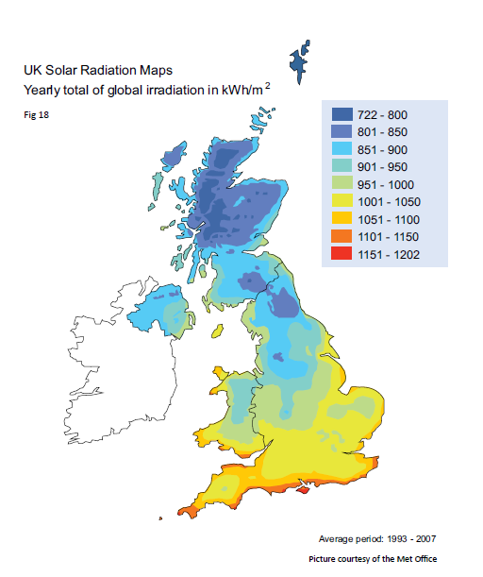The variation in irradiance across the UK is shown on the following map:

Typical daily and annual insolation curves, together with the monthly and seasonal trend in system

performance are shown in the charts below.

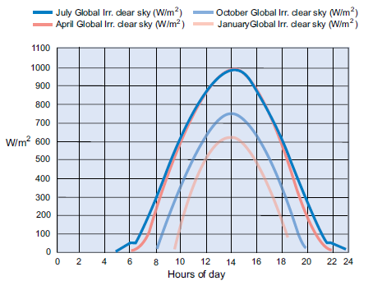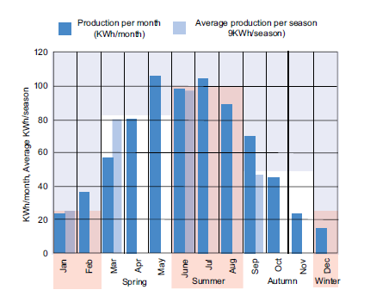

**Standard Estimation Method**

The approach is as follows:

1. Establish the electrical rating of the PV array in kilowatts peak (kWp)

No. of panels installed x kWp for the panel

1. Determine the postcode region

See postcode region map below

1. Determine the array pitch

This is the degrees from horizontal of the panels and is generally the same as the roof pitch (unless installing on a frame on a flat roof)

1. Determine the array orientation

This is the azimuth angle of the modules relative to due south, so for an array facing due south the azimuth is 0°, southeast or southwest would be 45° and east or west would be 90°, the azimuth is rounded to the nearest 5°

1. Look up kWh/kWp (Kk) from the appropriate location specific table

See map of zones below

6. Determine the shading factor of the array (SF) according to any objects blocking the horizon -

using shade factor procedure.

The estimated annual electricity generated (AC) in kWh/year of installed system shall then be

determined using the following formula:

**Annual AC output (kWh) = kWp x Kk x SF**

The postcode region can be determined from the map of zones below. Your property is in zone 6.

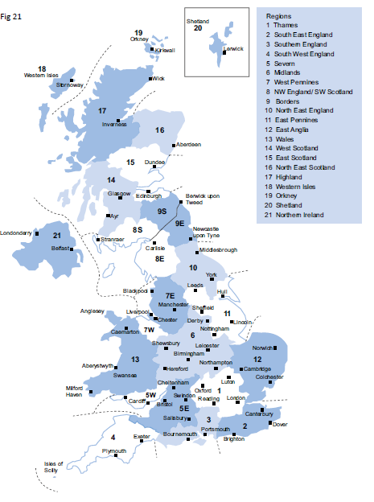

The sun path diagram below shall be used to produce a shading analysis for all estimates. Where there is an obvious clear horizon and not near or far shading, the assessment of SF can be omitted and an SF value of 1 used in all related calculations.

**APPENDIX B: Determining the self-consumption of a solar PV system with and without electrical energy storage**

The information below is based on the MCS Guidance Document: MGD 003 and should be used in conjunction with this document and the look-up tables within the document and is only applicable in a domestic situation.

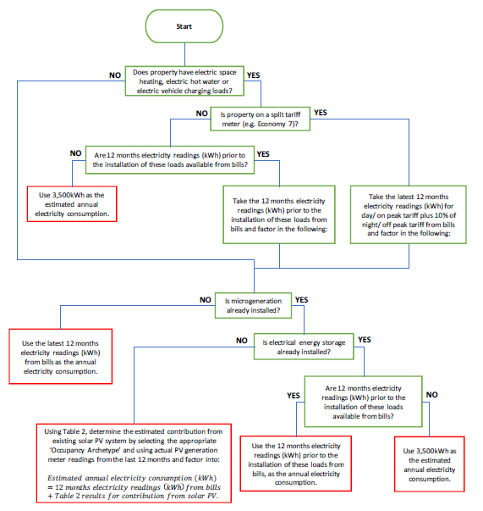The annual consumption is the total amount of electricity consumed in the domestic property in kWh in a full 12-month period. Depending on the circumstances, this should be derived in one of the following ways:

The quotable self-consumption of solar PV generation where there is NO ELECTRICAL ENERGY STORAGE is determined as follows:

Total solar PV

Generation per annum(kWh)

Solar PV generation directly consumed within domestic property over a year (kWh)

Self-consumption

= from lookup table (%) X

*PV only*

*Note self-consumption cannot exceed 95% of the total annual generation*

Grid electricity independence (%) =

Solar PV electricity self-consumption (kWh)

Annual electricity demand (kWh)

**Determination of Self-consumption with and without electrical storage**

|  |  |
| --- | --- |
| **Address of Customer** |  |
| Occupancy archetype |  |
| Total annual electricity consumption, kWh |  |
| Table used for electricity consumption |  |
| Total annual electricity generation from solar PV system, kWh |  |
| Row used for electricity generation |  |
| Usable capacity of electrical energy storage device, kWh |  |
| Column used for self-consumption with electrical energy storage |  |
| Table used |  |
| Self-consumption without electrical energy storage device, % |  |
| Self-consumption without electrical energy storage device, kWh |  |
| Self-consumption with electrical energy storage device, % |  |
| Self-consumption with electrical energy storage device, kWh |  |
| Grid electricity independence without electrical energy storage device, % |  |
| Grid electricity independence with electrical energy storage device, % |  |

**Return On Investment Breakdown:**

|  |  |  |  |  |  |  |  |  |  |
| --- | --- | --- | --- | --- | --- | --- | --- | --- | --- |
| **Year** | **Current Cost Per kWp** | **Output kWh** | **Total Annual Cost** | **Total Revenue** | **Cash Flow** | **Borrowed Amount** | **Loan Repayment** | **Interest Amount** | **Final Balance** |
|  |  |  |  |  |  |  |  |  |  |
|  |  |  |  |  |  |  |  |  |  |
|  |  |  |  |  |  |  |  |  |  |
|  |  |  |  |  |  |  |  |  |  |
|  |  |  |  |  |  |  |  |  |  |
|  |  |  |  |  |  |  |  |  |  |
|  |  |  |  |  |  |  |  |  |  |
|  |  |  |  |  |  |  |  |  |  |
|  |  |  |  |  |  |  |  |  |  |
|  |  |  |  |  |  |  |  |  |  |
|  |  |  |  |  |  |  |  |  |  |
|  |  |  |  |  |  |  |  |  |  |
|  |  |  |  |  |  |  |  |  |  |
|  |  |  |  |  |  |  |  |  |  |
|  |  |  |  |  |  |  |  |  |  |
|  |  |  |  |  |  |  |  |  |  |
|  |  |  |  |  |  |  |  |  |  |
|  |  |  |  |  |  |  |  |  |  |
|  |  |  |  |  |  |  |  |  |  |
|  |  |  |  |  |  |  |  |  |  |